**Paper reading**

1. **Feature diversity for fall detection and human indoor activities classification using radar systems**

Main idea: This paper presents preliminary analysis of radar signatures for fall detection and classification of human indoor activities, to monitor the daily behaviour of individuals at risk of deteriorating physical or cognitive health. This paper introduces two datasets of signatures of human activities, one of which includes simultaneous radar and RGB-D signatures enabling the investigation of suitable multisensory classification techniques for this context. Preliminary results are presented, regarding the analysis of the radar data, showing promising classification accuracy and referring to the final version of the manuscript for the analysis of the RGB-D data and their joint use.

Contribution:

1)Centroid and bandwidth of the signatures, the centre of mass of the spectrograms and the intensity of the signatures around it. The mean and the standard deviation of these two quantities have been previously used for human micro-Doppler classification .

2)Entropy of the spectrogram image and skewness of the histogram containing the intensity samples. These textural features have been previously used to discriminate human targets from other classes of targets.

3)Features based on Singular Value Decomposition (SVD), in particular the mean and the standard deviation of the first three vectors of the left (U) and right matrix (V) resulting from the decomposition. These have been previously used for classification of unarmed vs potentially armed personnel and for micro-drones’ payloads classification.

1. **Robust RGB-D SLAM in Dynamic Environment Using Faster R-CNN**

Main idea : This paper proposed a method which is used in dynamic environment. We first check whether there are objects moving by the threshold which represents consistency of matching and identify every potential candidate of the dynamic object. If the dynamic existence is confirmed, we compute the dynamic region and figure out the dynamic object efficiently. Then we will cull the wrong data association in dynamic region and add more new data association we don’t have in static region.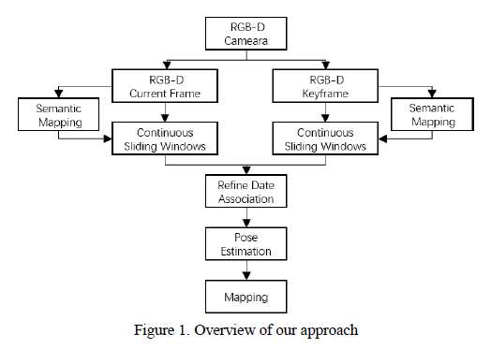

1. Use Faster-RCNN to detect and identify the potential candidate of the dynamic object whose category will be labeled.

2. Distinguish the stationary from the dynamic environment and refine the data association by removing the mismatching related to the dynamics.

They compute the consistency of the point J in corresponding object regions.

$$J=\sqrt{\frac{1}{N}\sum_{i=1}^{N}{{\left.X_{i}^{h}-(R_{h,k}X_{i}^{k}+t_{h,k})\right\|}^{2}}}$$

It means that we project the feature points in the stationary region of the current frame k into the corresponding region of the keyframe h with the estimated camera pose $T_{h,k}$. Then they compute the similarity between these. If the J is over the threshold, they label the region of object as dynamic status from stationary status and update the data association by filtering out the data associations in the moving region. Once the status is dynamic, there’s no chance for status to turn back. If the J is within the threshold, they label the region as stationary state and reserve previous data association.

3. Estimate the camera pose with better data association and the optimization of the graph.

4. With accurate pose estimation, they reconstruct the dynamic environment successfully.

1. **Loop Closure Detection for Visual SLAM Systems Using Convolutional Neural Network**

Author: Xiwu Zhang

Publication: Proceedings of the 23rd International Conference on Automation & Computing, University of Huddersfield , Huddersfield, UK, 7-8 September 2017

Main idea:

We propose a loop closure detection method based on convolutional neural networks

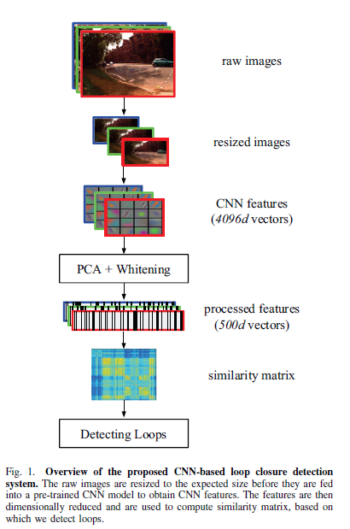

1. Normalization: For each feature vector extracted from CNN model, we perform normalization step as follows:
$$\left(v_{1},…v_{d}\right)←(\frac{v_{1}}{\sqrt{\sum_{j=1}^{d}{v_{j}^{2}}}},…\frac{v_{d}}{\sqrt{\sum_{j=1}^{d}{v_{j}^{2}}}})$$

2. PCA Dimensionality Reduction: Suppose we have obtained normalized feature vectors and the corresponding matrix 𝑋 consists of these vectors is:

$$X=\left[\begin{matrix}V^{I1} \\ V^{I2} \\ \begin{matrix}… \\ V^{In}\end{matrix}\end{matrix}\right]$$

a principal component analysis procedure is performed as the following algorithm:

Let $\overline{V}=\frac{1}{n}\sum_{i=1}^{n}{V^{(Ii)}}$

For i=1 to n do

Replace $V^{(Ii)}$ in X with $V^{(Ii)}-\overline{V}$

End for

$$cov=X^{T}X$$

$$\left[U,S,W\right]=svd(cov)$$

$$V_{reduced}^{Ii}=V^{Ii}U[:,:500]$$

1. Whitening: they whitened each feature vector according to the form:
$$V_{whitened,j}^{(Ii)}=\frac{V_{reduced,j}^{(Ii)}}{\sqrt{λ_{j}+ε}}$$

2. Euclidean distance:
$$D\left(i,j\right)={\left\|\frac{V_{w}^{Ii}}{{\left\|V_{w}^{Ii}\right\|}_{2}}-\frac{V_{w}^{Ij}}{{\left\|V_{w}^{Ij}\right\|}_{2}}\right\|}_{2}$$

3. Similarity score :

$$S\left(i,j\right)=1-\frac{D(i,j)}{max⁡\{D(i,j)\}}$$

If the similarity score is larger than a specific threshold, we regard it as a loop